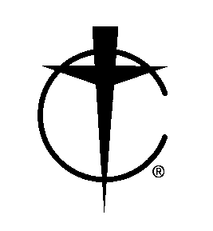
26th National Cursillo® Encounter

Lewis University, Romeoville, IL

August 4 - 7, 2016

Last Name: |  |  |  | First Name:
Address: |  |  |  | City/State/Zip:
E-Mail: |  |  |  | Phone:
Diocese: |  |  |  | Region #:
Language Group: |  |  |  | Male or Female:
Select one: ☐Bishop ☐Priest ☐Deacon ☐Vowed Religious ☐Laity
Select one: ☐Spiritual Advisor ☐Assist. Spiritual Advisor ☐Lay Director ☐Other:
If you wish to room with a specific person (spouse, friend, relative) then the other person's registration form must accompany this form.
Do you have a roommate preference? If yes, provide name:
Need assistance - physically challenged? Describe need:
Make checks payable to: National Cursillo Center. Accept Visa, MasterCard, Discover, American Express
Registration Fee is $345.00 per person. Full payment and this form must be received by June 15, 2016. Registration fee increases to $400.00 per person beginning June 16, 2016. Unable to guarantee registration after June 30, 2016.
Credit card type: |  |  | Card Number:
Name on Credit Card: |  |  | Expiration Date:
Voucher # (if any): | Discount: |  | Amount Submitted:

Please use a separate Registration Form for each person. Type or print legibly and fill in all spaces as applicable.

Send this form and payment to:
National Cursillo® Center

P.O. Box 799

Jarrell, TX 76537
512-746-2020
admin@natl-cursillo.org

There is a $40.00 non-refundable fee for all cancellations through May 31, 2016. No refunds after May 31, 2016.
The National Cursillo® Center is responsible for payment to Lewis University regardless of cancellations.

