25th National Cursillo® Encounter
Villanova University, Villanova, PA
Frequently Asked Questions

What is the date of the Encounter?  Thursday, July 23 – Sunday, July 26, 2015.  Where is the Encounter being held?  Villanova University, 800 Lancaster Avenue, Villanova, PA 19085.  What is the Encounter registration fee?  - $325.00 per person if the Encounter Registration Form is received by June 15, 2015.  - Registration fee increases to $400.00 per person on June 16, 2015.  - Unable to guarantee attendance after June 30, 2015. | 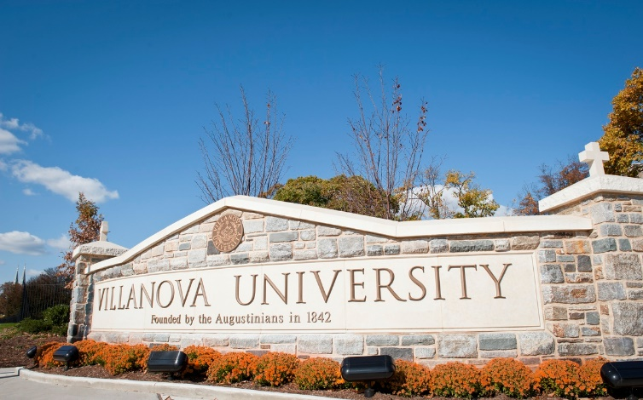
Can the Encounter registration fee be paid in payments?
No, full payment per person must accompany the Encounter Registration Form.

How do I register for the Encounter?
You may register on-line at https://www.natl-cursillo.org/encounter/ or download a registration form and mail form with full payment to the National Cursillo® Center, P.O. Box 799, Jarrell, TX 76537. You can also fax form to 512-746-2030, or e-mail form to admin@natl-cursillo.org . Use a separate Encounter Registration Form for each person.

There is a $40.00 non-refundable fee for all cancellations up until May 31, 2015. No refunds after May 31, 2015 – No exceptions! The National Cursillo® Center is responsible for payment to Villanova University regardless of cancellations.

How do I pay for Encounter registration fee?
Payment can be made with Visa or MasterCard credit cards only or personal check. Make checks payable to National Cursillo® Center and mail to National Cursillo® Center, P.O. Box 799, Jarrell, Texas 76537. Lay Directors can also redeem vouchers received from the $3/yr donation campaign to pay for the Encounter registration fee.

Do I need to bring bed linens, etc?
The University will provide bed linens, blanket, towel, and pillow.
What time is check-in?
Check-in is from 2:00 p.m. – 8:00 p.m on Thursday July 23.

What time does the Encounter begin?
Dinner will be served from
5:00 p.m. – 7:00 p.m.

Opening of the 25th National Cursillo Encounter will begin at 7:30 p.m. at Villanova Room - Connelly Center.

What time is check-out?
Cursillistas must check-out by 10:00 a.m. on Sunday, July 26, 2015.

What airport will I be flying into?
Villanova University is 25 minutes from Philadelphia International Airport (PHL). Complimentary transportation from/to Philadelphia International Airport will be provided on Thursday July 23 and Sunday July 26, 2015.

What does registration fee include?
The registration fee includes three nights lodging, dinner on Thursday evening, 3 meals on Friday and Saturday, and breakfast on Sunday morning.

NOTE: Participants are responsible for their own lunch on Thursday. Lunch is not included in the registration fee.

Where can I get a campus map and driving directions to Villanova University?
See this link below:
http://www1.villanova.edu/villanova/services/conferenceservices/directions.html

What is the lodging capacity and set-up for the Encounter?
750 persons. Two persons per bedroom.

Where can I send Palanca for the Encounter?
E-mail palanca letters to: annbatiste@hotmail.com

